Quarch Technology Ltd

AN-016

Application Note

QPS automation with Iometer

For use with:

**XLC Power Modules  
HD Power Modules**

**Quarch Power Studio (QPS)**

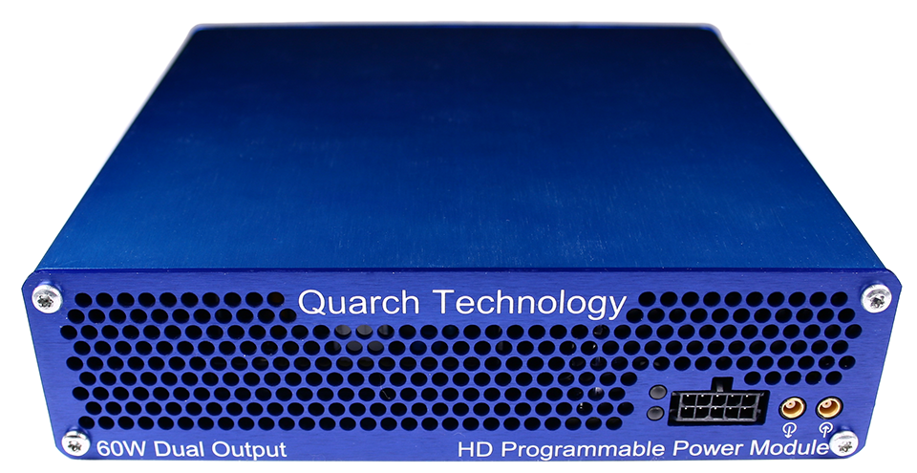

# Change History

|  |  |  |
| --- | --- | --- |
| 1.0 |  | Initial Release |
|  |  |  |
|  |  |  |
|  |  |  |
|  |  |  |

Contents

Change History 2

Introduction 4

Modules Supported 5

System Supported 5

Application Note Example Files 5

Installation and setup 6

Python install 6

QuarchPy library install 6

Java install 8

QPS install 8

Additional library install 8

Power module setup 9

Running the example 10

# Introduction

Quarch Power Studio (QPS) is a unique system for recording and analyzing power consumption of storage devices.

This application note demonstrates the ability to automate QPS and bring in user data from another source

In this example, we will use Iometer to drive traffic to a device and plot both power and performance as part of a fully automated test.

This example was demonstrated at FMS2018

# Modules Supported

XLC power modules

* QTL1824 (QTL1824-02A modules do NOT support streaming, but can be upgraded by Quarch)
* QTL1847

HD power modules

* QTL1995
* QTL1999

# System Supported

This example is written for windows, though could be converted to Linux if the drive identifying functions were re-written.

It currently requires Python 2.x

## Application Note Example Files

The **AN-016.zip** should be extracted to your preferred location.

# Installation and setup

## Python install

If you do not already have Python installed, download and install it from:

<https://www.python.org/downloads/>

Under Windows it is helpful to make sure the Python installation directory and PythonXX\Scripts are included in the PATH environment variable. See:

<https://docs.python.org/2/using/windows.html#excursus-setting-environment-variables>

## QuarchPy library install

The Quarch Python package can be installed from the Python web repository (assuming you have internet access) or via the download from our website.

Quarchpy will also install a version of Quarch Power Studio

### Web Install

From the command line:

**>pip install quarchpy**

If this fails, your path to “pip” may not be set, you can instead run:

**>python –m pip install quarchpy**

### Local Install

If you want to install from a downloaded folder, ensure the folder is unzipped to a local disk, navigate to the folder containing the setup.py file and run (noting the ‘.’ on the end):

**>pip install quarchpy .**

If this fails, your path to ‘pip’ may not be set, you can instead run:

**>python –m pip install quarchpy .**

### Upgrade

If you already have QuarchPy installed, you will get a failure message. If you want to upgrade to a new version, you need to add the ‘--upgrade’ command:

**>pip install --upgrade quarchpy**

The --upgrade command can similarly be used in any of the other examples, to load from a local install folder.

## Java install

Check that the Java JRE is installed

You can find install instructions and files here:  
<http://www.oracle.com/technetwork/java/javase/downloads/index.html>

## QPS install

Current versions of QPS are provided as a portable (non-install) .jar file

The latest version can be downloaded from here:  
<https://quarch.com/products/quarch-power-studio>

## Additional library install

The example script makes use of win32 calls in order to identify the Iometer targets

You will need to install wmi and pywin32

**>pip install wmi**

**>pip install pywin32**

## Power module setup

Connect the power module to the test PC and the output of the power module to the drive under test.

Customer Drive

USB/LAN Connection

Power Module

Customer Test PC

# Running the example

You must run the script with **administrator** privileges to work

* When run, you will be prompted to select a target to run on, ensure that you select the correct drive, or the Iometer test may erase important data!

Select the drive that the power module is attached to.

* You will be prompted to select the Quarch power module you want to connect to.
* The script will now launch Power Studio, this may take a few seconds
* The script will iterate through every .conf file in the root /conf folder of the application note folder.

Each .conf file is a renamed Iometer .icf file, with no target information

The script will take each .conf file, add the required target information for each worker and then execute it with Iometer. This means you can create any number of your own .conf files and drop them in the folder to be executed.

* As each Iometer run is executed, the script will:
  + Display the real time power consumption
  + Annotate the start and end of each test
  + Parse the iometer ‘instresults’ file and add the second-by-second performance data onto the chart

